ASSIGNMENT 4

OUTPUT

* Spring-rest-hands-on-01
* Create a Spring Web Project using Maven

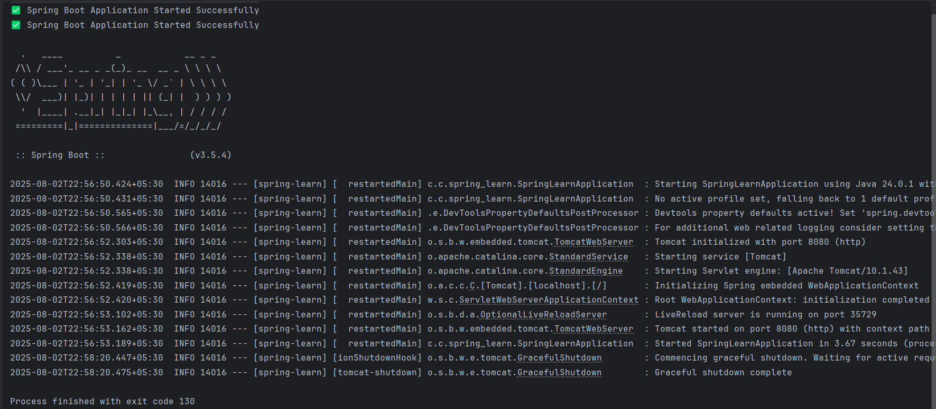

* Spring Core – Load Country from Spring Configuration XML

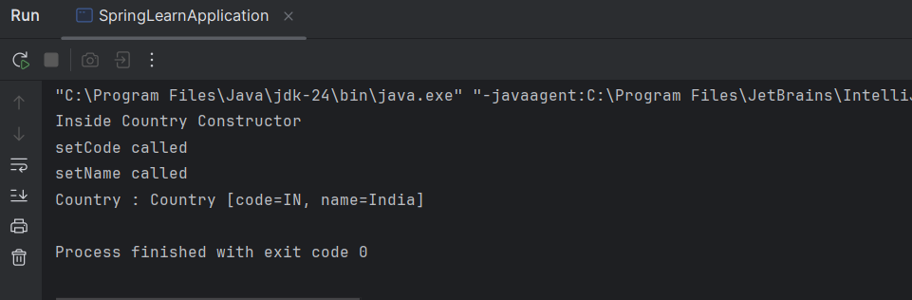

* Spring-rest-hands-on-02
  + - Hello World RESTful Web Service

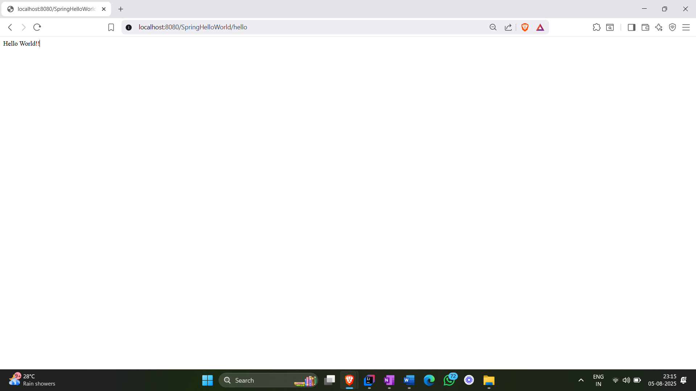

* REST - Country Web Service

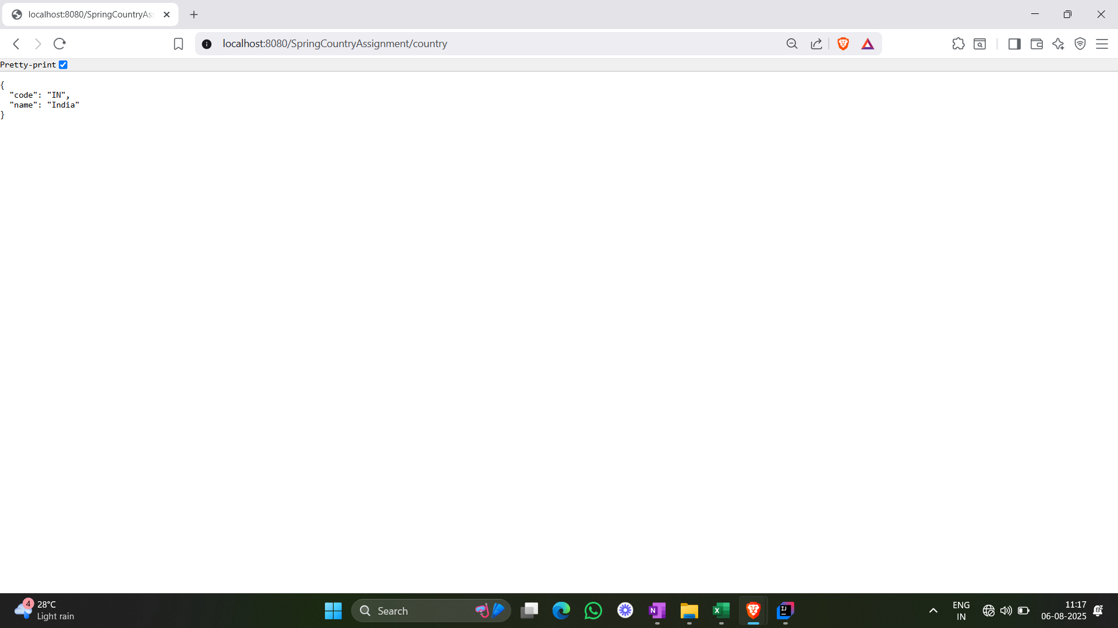

* REST - Get country based on country code

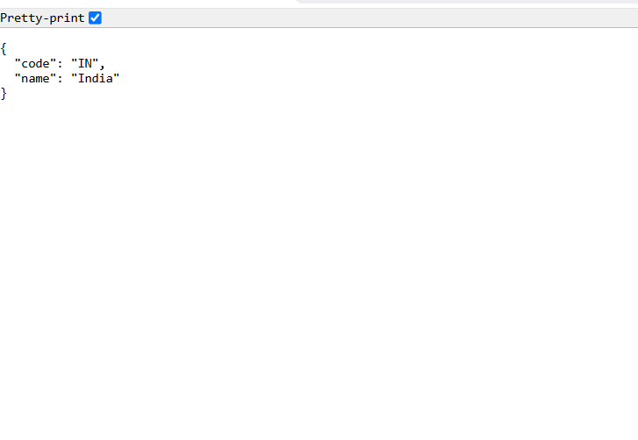

* Spring-rest-hands-on-05
  + Create authentication service that returns JWT

